Empirical Tribe 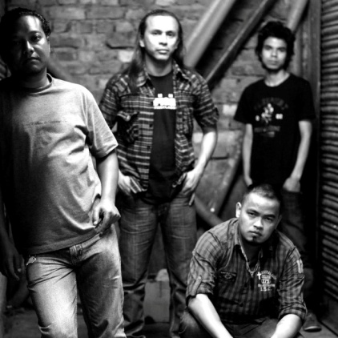
Band Profile :

It has been said that a name can tell much about a person, place or thing. The name Empirical Tribe speaks much about the origin of the band and its music. Empirical means 'something that is based more on experimentation and observation rather than theoretical laws' and the term Tribe reflects the diverse cultures and communities of the North-eastern part of India.
The band was formed in 2009 and had the following line-up:
Gregory Fancon - Vocals (2009 - present)
Rocky Lyngdoh - Guitars (2009 - present)
Banshan Nongkhlaw - Drums (2009 - present)
John Lyngdoh - Bass (2009 - 2012)
The band has made two line-up changes till date, with Anthony Sohtun providing additional vocals and Khlain Ryntathiang replacing John Lyngdoh on the bass which further added more variation and solidness to the band as Khlain had been playing bass in quite a few established rock acts in Shillong.
The first performance of the band was in 2009 itself and from there onwards, the band moved by leaps and bounds to becoming one of the top rock acts in Shillong today. The first taste of success and recognition for the band's talent and efforts came in the form of Greg winning the award for the Best Vocalist at the prestigious Meghalaya Icon 2 in 2011. The next big leap for the band happened in November, 2011 when they were the winners in the Kolkata Autumn Music Festival organized by the American Center, Kolkata. This put them in the forefront of the Shillong music scene which was heavily dominated by pop, commercial rock and underground heavy metal.
The band's unique sound stems from a varied but seamless blending of the band members' individual tastes and influences. The band's style of music can be described as 'hard rock with a progressive and melodic edge' and the band's songs are mostly about life itself and the present state of the society as a whole. The band's collective influences range from rock bands like Europe, Gotthard, Skid Row to progressive acts like Dream Theatre, Queensryche, Circus Maximus and even to metal bands like Lamb of God and Korn. However the band has its own distinctive and unique sound which, no doubt sets them apart from the other rock bands from Shillong and it has become somewhat of a trademark for the band.
The band is currently focused on songwriting and recording, and they hope to come out with an album in the very near future which no doubt, will be a treat for music lovers and the fans of rock music alike.

