Technical rider & Stage plan
First of all, thank you for your interest in booking a show for The Monkberries. Below is a list of our technical requirements. It might sound a bit formal to you, this is not meant to cause any inconveniences on your behalf. We designed this rider for optimum effectiveness at the day of the show. If there are any questions or if you have trouble providing any of the below mentioned please get in touch with us before the day of the show and we will work out a solution.
Booking and payment details:
- Total amount for the performance would be ON REQUEST ss(excluding of everything e,g tax, staying, fooding and transportation etc) 1 and a half hours to 2 hours performance (approx)
- 50% advance to be made during the time of confirmation and the rest 50% one day prior the show date. Preferable payment mode is cash or demand draft.
- For Neft transfer, we will provide you with the bank details once the show is confirmed.

Hospitality and Travelling :
- 6 people will be travelling. So, 6 Flight tickets or AC 2 tier train tickets to and fro has to be provided (if there is no flight service in that area)
- Cars for pick and drop from/to Airport or Railway station
- 3 AC double bed room.
- During our stay fooding and non alcoholic beverages to be taken care by the organizers.

Technical rider & Stage plan
Our Stage Setup is:
1 Drumset (an imported set to be provided by the organizers)
1 Bass Guitar
2 Lead/ Rhythm Guitars
1 Keyboard
4 Vocals
We assume that there is a well sized PA system provided for the concert area with sufficient power to supply a clean and undistorted 110dB SPL RMS to the mixing desk and a powerful and feedback-proof minimum 6 monitors. It is very important that the singers and the drummer each have their own monitor speakers with separate mixes. For venues over 300 people we will need two extra monitors for the guitar players and two side fills for really large venues.

In EAR Monitors are a must for Vocalist, Guitarist and Bassist and Side fills for large venues/ concerts.
contact The Monkberries (Primary Contact)
Tel (road): 9830228729 / themonkberries@gmail.com

Technical rider & Stage plan
The Minimal Set up for small venues:
Microphones are listed in order of preference (if available/ Similar quality)
Drums :
KICK
SNARE
OVERHEAD LEFT

OVERHEAD RIGHT

B ASS GUITAR

GUTAR

KEYBOARD

VOCALS
AKG D12E, Sennheiser MD421, Electro Voice PL20 / RE20, Beyer M88, AKG D112
Shure SM57
Neumann or Gefell small diaphragm condenser, AKG C451, small diaphragm condenser
Neumann or Gefell small diaphragm condenser, AKG C451, small diaphragm condenser
amplifier has DI output

amplifier has DI output

amplifier has DI output

Shure SM58
The complete set up :
For Large Venues (microphones are listed in order of preference and availability/ similar quality)

Drums
KICK

SNARE TOP
SNARE BOTTOM
HIHAT

RACK TOMS
FLOOR TOM
OVERHEADS

B ASS

AKG D12E, Sennheiser MD421, Electro voice PL20 / RE20, Beyer M88, AKG D112
Shure SM57
Shure SM57
Neumann or Gefell small diaphragm condenser, AKG C451, any small diaphragm condenser
Sennheiser MD421, Beyer M88, any suitable dynamic mic
Sennheiser MD421, Beyer M88, any suitable dynamic mic
Neumann or Gefell small diaphragm condenser,
AKG C451, any small diaphragm condenser (left & right) amplifier has DI output or choose external DI interface

GUTAR amplifier has DI output

BASS GUTAR amplifier has DI output

KEYBOARD amplifier has DI output

VOCALS Shure SM 58

Technical rider & Stage plan
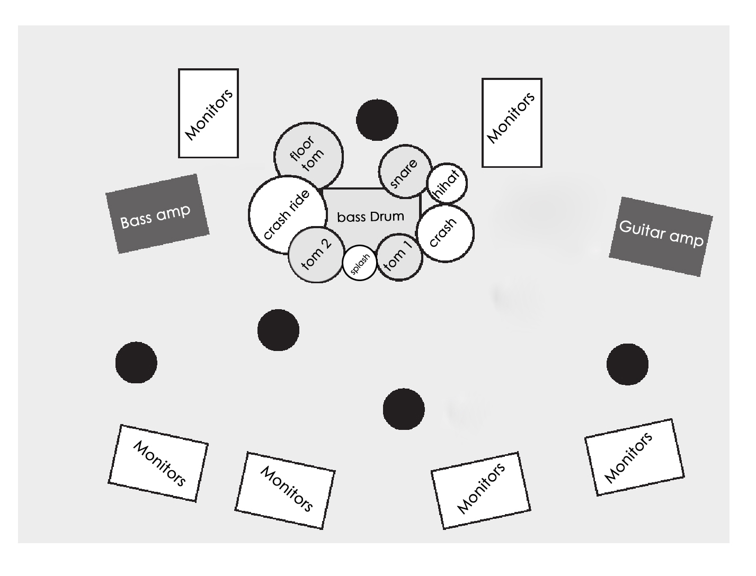
Stage Plan :

Additional Equipments:
Floor carpet (approx. 160cm x 200cm) for drums on the stage and separate Drum platform/ podium.
Staff
We will need a qualified sound engineer, stage technician and lights technician. We depend heavily on the staff on-site to coordinate with our own Engineers and technicians.
Sound & lighting
We prefer an overall natural sound with processing and effects. The drums need not have clicky attack sounds, please use gates only when unavoidable and with great care. The vocals are best left with normal reverberation, maybe a bit of a very short delay on the main singer and a touch of short ambience on the backup singers. The main singer has a very large dynamic range, please do not use compression. Lighting can be discussed during soundcheck, it is important though that during the show there is always sufficient light for the bass and guitar players to see the fretboard of their instruments.
Soundcheck
We will need an absolute minimum of 45 minutes soundcheck, 60 to 90 minutes including setup would be perfect.
Arrival
Please provide detailed directions in English, Hindi or in Bengali language two days atleast before the date of the show with the complete address of the venue and a telephone contact. We need a safe parking space available for the van close to the venue. Please provide arrival, soundcheck and doors-open and on-stage times. The promoter or another person should be at the venue at arrival time.

Food & Drinks
6 non- vegetarian meals (1 Veg meal on Fridays)
minimum 6-7 bottles of cooled non-carbonated water and 6-7 Redbulls (or similar drinks) for stage and backstage
Fooding and Staying for 6 person.*
Backstage
A separate room for the band to get some rest before and after the show. It would be great to have some sofas, tables, chairs, a mirror and sink.
Sleep
A warm, clean, dark and quiet accommodation for 6 persons with proper bed, bath room, shower and mirror. A safe parking space near the sleeping accommodation should be available.
Miscellaneous
Type of Crowd and the average age of the audiences.
Advertising & Promotion
There `s a fair amount of promo material we can send to you for advertising purposes.
Don`t hesitate to write, if you need posters or flyer and promo templates, logos or pictures in various file formats. Just get in contact with us. There`s no corporate identity in our
advertising, but a corporate feeling for what the band is. We appreciate good design, whether it`s professional or just made from the heart.

Thanks a Lot

